/* PROGRAM TO CHECK IF GIVEN CHARACTER IS VOWEL OR CONSONANT*/  
  
#include<stdio.h>

int main()

{

char character,a,e,i,o,u;

printf("enter any character ");

scanf("%ch",&character);

if (character=='a'||character=='e'||character=='i'||character=='o'||character=='u'||character=='A'||character=='E'||character=='I'||character=='O'||character=='U'){

printf("your charcater is a vowel", &character);

}

else {

printf("your character is consonant");

}

return 0;

}  
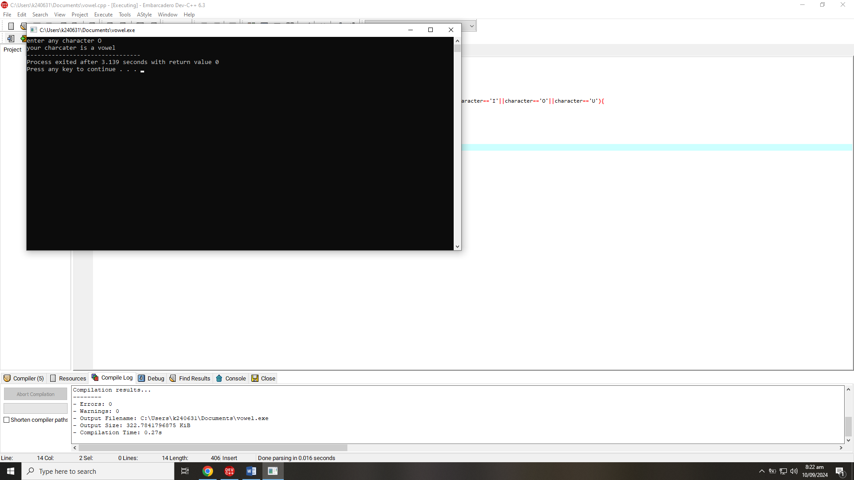

/*Write a C program that describes the temperature as "Cold" (below 10°C), "Mild" (10-25°C), or "Hot"(above 25°C).*/

#include<stdio.h>

int main()

{

int temp;

printf("enter temperature in centigrade ");

scanf("%d",&temp);

if (temp<10){

printf("temperature is cold");

}

if(temp>=10&&temp<=25){

printf("temperature is mild");

}

else {

printf("temperature is hot");  
 }  
return 0;  
}

}

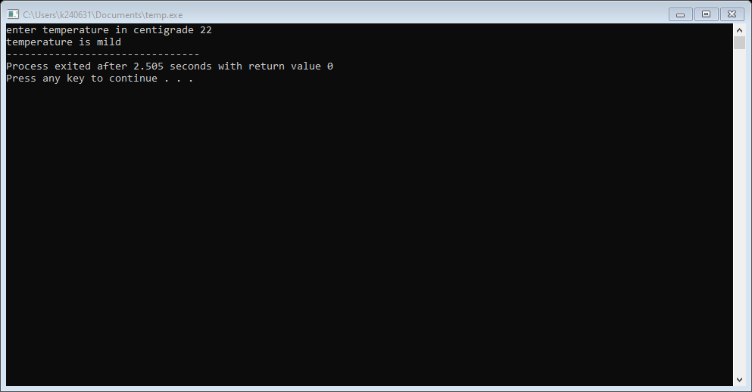

/*Write a C program that checks if a student is eligible for a scholarship. The student must have a GPA of 3.5 or higher. If this condition is met, further check if the student has extracurricular activities, making them eligible.*/

#include<stdio.h>

int main()

{

float GPA;

char answer,y,n;

printf("enter your gpa= ");

scanf("%f", &GPA);

scanf("%*c");

if (GPA>=3.5){

printf("do you have any extracirricular activites? (y/n)\n");

scanf("%c",&answer);

if(answer=='y'){

printf("you are eligible for scholarship");

}

else {

printf("you are not eligible for scholarship");

}

}

else {

printf("your gpa is below minimum requirement");

}

return 0;  
}

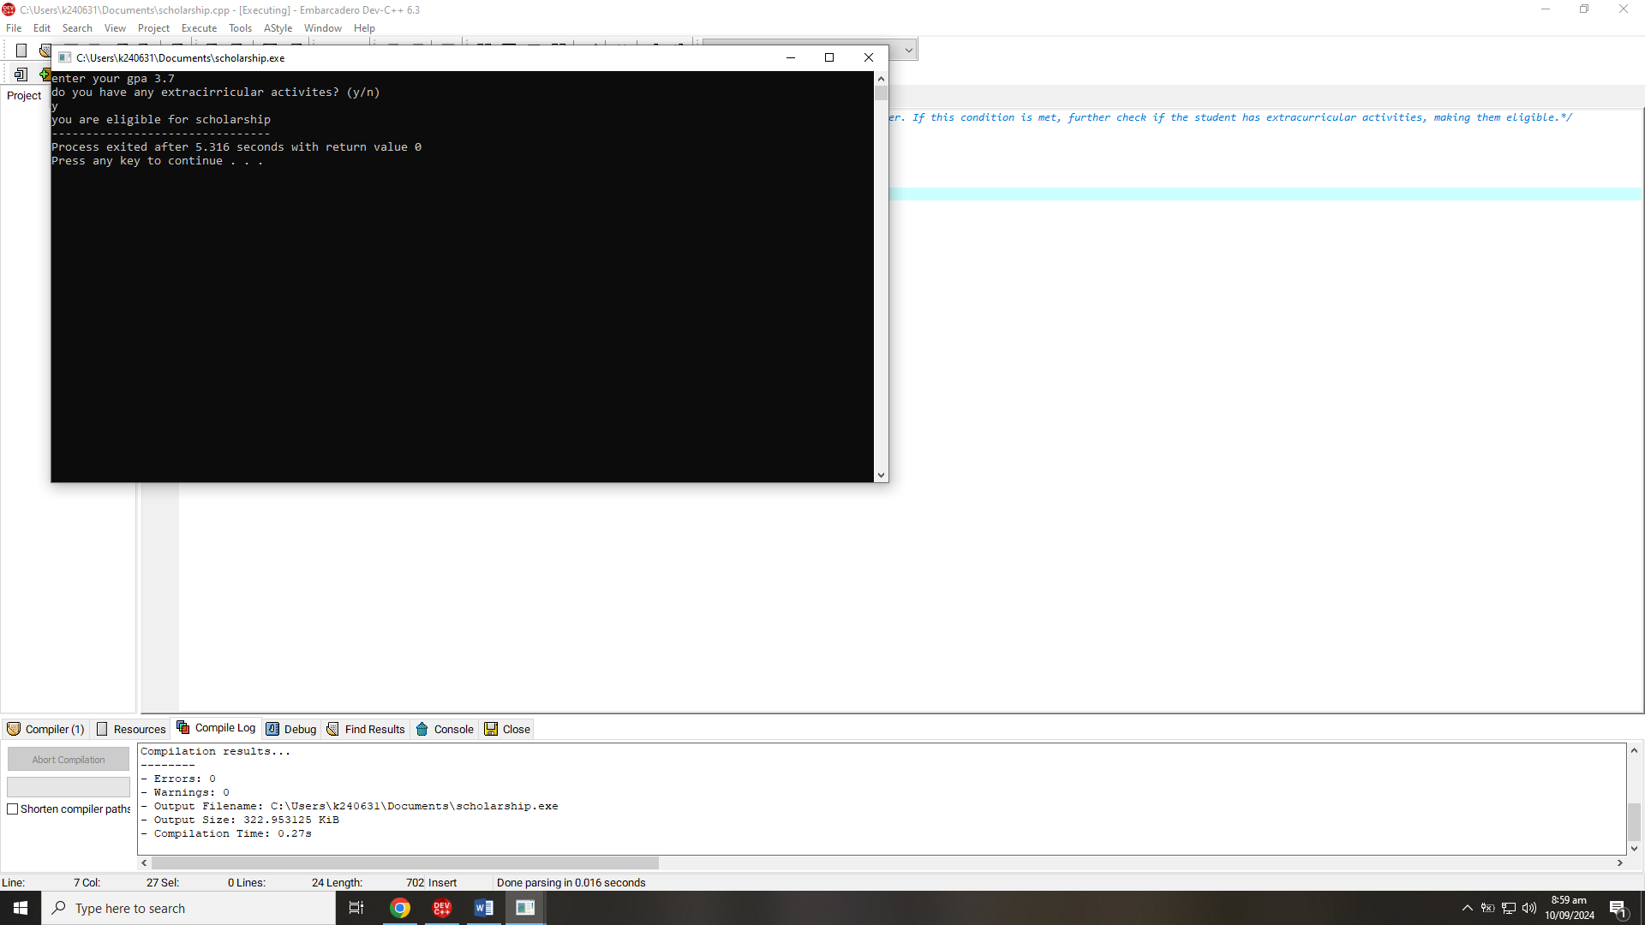

/*Input two numbers and determine whether the numbers are equal or not, if numbers are not equal then determine which one is greater and which one is less.*/

#include<stdio.h>

int main()

{

int n1,n2;

printf("enter any number n1 ");

scanf("%d",&n1);

printf("enter any number n2 ");

scanf("%d",&n2);

if (n1!=n2) {

printf ("the two numbers are not equal\n");

if (n1>n2){

printf("n1 is the greater number, n2 is less than n1");

}

else {

printf("n2 is the greater number, n1 is less than n2");

}

}

else {

printf("the two number are equal"); }

return 0;

}

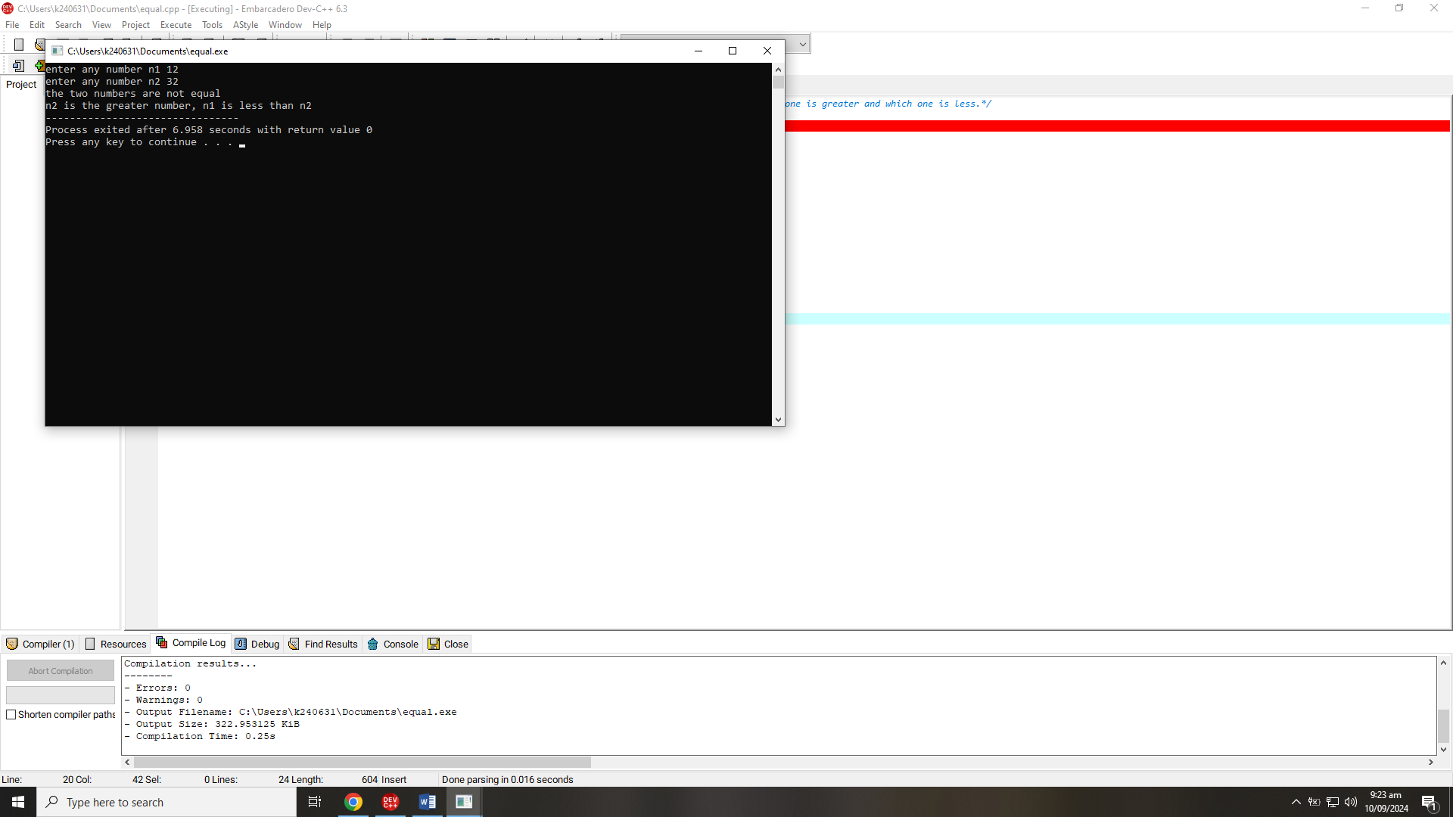

For Motorcycles (Vehicle Type M):

• Model 1: Cruiser, 250cc

• Model 2: Sports, 600cc

• Model 3: Dirt Bike, 450c*/

#include<stdio.h>

int main()

{

char vehicle_type, c,m;

int model;

printf("enter your vehicle type, [car (c) or motorcyle (m)] ");

scanf("%c",&vehicle_type);

printf("enter your model type (1-3) ");

scanf("%d",&model);

if (vehicle_type=='c'){

switch (model){

case 1:

printf("Model 1:\n sedan \n 1500cc \n 4-door");

break;

case 2:

printf("Model 2:\n hatchback \n 1300cc \n 5-door");

break;

case 3:

printf("Model 3:\n SUV \n 2000cc \n 4-door");

break;

default:

printf("invalid input\n");

}

}

else {

switch (model){

case 1:

printf("Model 1:\n Cruiser \n 250cc ");

break;

case 2:

printf("Model 2:\n Sports \n 600cc ");

break;

case 3:

printf("Model 3:\n Dirt Bike \n 450cc ");

break;

default:

printf("invalid input\n");

}

}

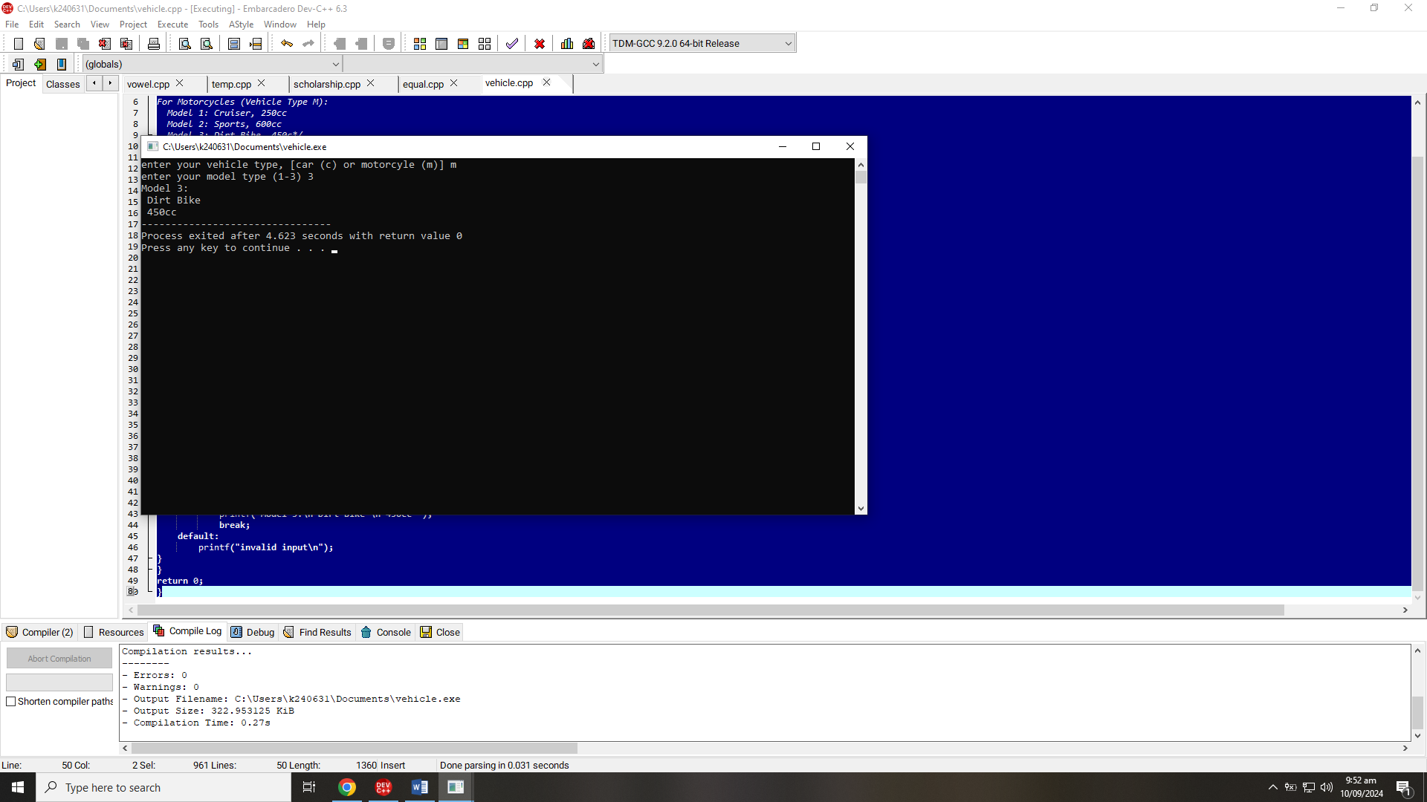return 0;   
}

/*The body mass index (BMI) is the ratio of the weight of a person to the square of the height. Write a program that takes two inputs, weight and height, computes the BMI, and prints the corresponding

BMI category:

• Starvation: less than 15

• Anorexic: less than 17.5

• Underweight: less than 18.5

• Ideal: greater than or equal to 18.5 but less than 25

• Overweight: greater than or equal to 25 but less than 30

• Obese: greater than or equal to 30 but less than 40

• Morbidly Obese: greater than or equal to 40*/

#include<stdio.h>

int main()

{

int height,weight;

float BMI;

printf("enter you height in inches ");

scanf("%d",&height);

printf("enter your weight in pounds ");

scanf("%d",&weight);

BMI= (weight*703.00) / (height*height);

printf("your BMI value is %.2f ", BMI);

if (BMI<15){

printf("Starvation \n");

}

else if (BMI<17.5){

printf("Anoeric");

}

else if (BMI<18.5){

printf("Underweight");

}

else if (BMI>=18.5&&BMI<25){

printf("Ideal");

}

else if (BMI>=30&&BMI<40){

printf("Obese");

}

else {

printf("Morbidly Obese");

}

return 0;

}

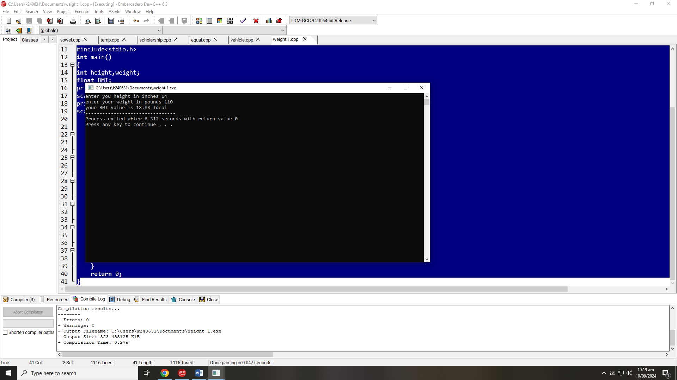

/*Write a C program that calculates the shipping cost based on the shipping method chosen by the user. The user will input a letter representing the shipping method:

• E: Express (Rs. 200)

• S: Standard (Rs. 100)

• O: Overnight (Rs. 300)

• R: Regular (Rs. 50)

Use a switch statement to determine the cost and print it. If the input is not one of these

letters, print "Invalid shipping method."*/

#include<stdio.h>

int main(){

char method;

printf("enter your shipping method ");

scanf("%c",&method);

switch (method){

case 'E':

printf("method = express, your shipping cost is rs 200");

break;

case 'S':

printf("method = standard, your shipping cost is 100 rs");

break;

case 'O':

printf("method = overnight, your shipping cost is 300 rs");

break;

case 'R':

printf("method = regular, your shipping cost is 50 rs");

break;

default:

printf("invalid input");

}

return 0;

}  
  
